Defending Our Symbols: Why It Matters

By LEA SVENDSEN

Original Link

In the aftermath of the Capitol Incident, I had the privilege to speak with a reporter from Religion News Service. Emily McFarlan Miller wrote a wonderful article about the heathen and pagan response to That Guy’s tattoos ft. our own Jason Mankey (and yes I know That Guy has a name, but I believe there’s power in using names, and I would rather not sully my writing space or my brain with it. This is one of the few times it’s a blessing to forget someone’s name immediately after hearing it!). Once again, I’m extending my gratitude to Ms. Miller for bringing attention to the pagan community’s condemnation of the siege and of the fallout we’re facing by having our religious symbols mistaken for icons of hate.
During our conversation, she asked me why I’d felt so compelled to write a reaction piece after seeing the tattoos. I was glad for the question, because it gave me a chance to point out the fact that really, this isn’t about us. To be honest, it’s not about defending our religion. The gods can take care of themselves. Besides, there’s nothing to defend: heathenry itself is a neutral philosophy. Yes, there’s emphasis on acting honorably and supporting our communities through good works and fellowship. Every religion can be perverted by the wrong people, and every religion has, no matter how perfect the philosophy.

We’re Part of a Larger Community
I feel so strongly about speaking about what our symbols represent and why it’s bothersome to see them used by those who wish to terrorize is, well, because terrorism doesn’t end in a photograph taken at the Capitol. I wear one of my many Mjolnir pendants daily along with a necklace inscribed with the runic version of Loki and Sigyn’s names. They’re articles of faith, worn for my own inspiration and protection, and I’m not going to stop or hide them because some brainwashed QAnon cultist played banana republic with a massive Mjolnir tattoo.
Defending Nordic symbols matters because I don’t live in isolation. I have a public facing job for my M-F 9-5, and I wear these pendants openly at work. I joke that management has lost their minds because I’m the last person who should be allowed to interact with the public due to my tendency to blurt out whatever snarky joke comes to mind, but my role involves talking to (or at least seeing) everyone who comes in for service. I secretly enjoy it because I like to chatter and make people laugh. I like people to feel comfortable and relaxed and leave with a smile, even if it’s a bemused “what the hell is wrong with that weird lady” kind of grin.
I live and work in a small city with an incredibly diverse population. My neighborhood is fantastic because my block alone is a cross-section of ethnicity, cultures, languages, and beliefs (during a recent snowstorm, five of us assembled in one of the alleys to help free a stuck minivan. Three different languages were spoken, and though we didn’t all understand each other’s words, we communicated flawlessly in our coordinated efforts between shoveling and pushing). It’s a really cool place to live, and I get along well with everyone.
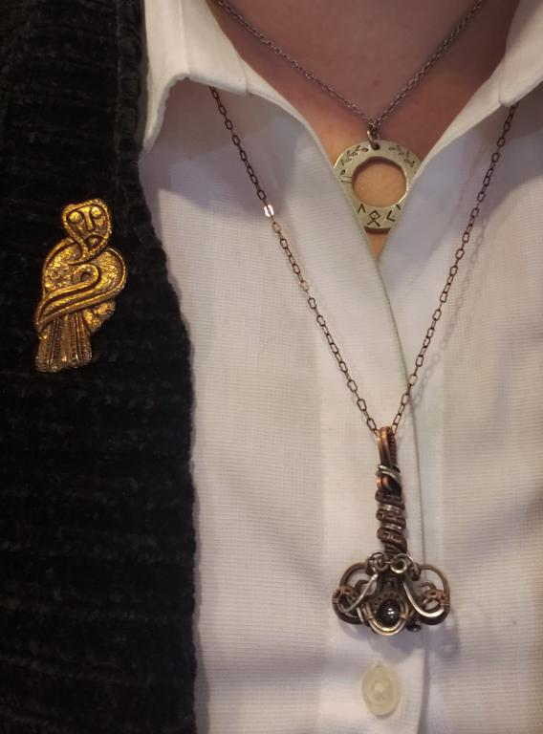

My daily drivers: Mjolnir, made by the wonderful Lapidify (Etsy) and my dual-sided Loki and Sigyn pendant. Oh, and a replica of the Birdman brooch discovered in Denmark, which I’m pretty sure is Loki wearing Freyja’s falcon cloak. That is the face of someone caught in the middle of mischief, you can’t convince me otherwise!

I’m an Ally. Please Don’t Be Afraid of Me.

The people I help at work are also a multitude of races and backgrounds and orientations, and with my Mjolnir and runes on full display at every interaction, it’s important that they don’t represent hate. There’s real concern about a BIPOC or member of the LGBTQA+ community seeing my Thor’s Hammer and connecting it to far-right extremism thanks to things like That Guy swanning around the Capitol. It’s not even that I don’t want people to mistake me for a bigot

– I don’t want anyone to be afraid of me or feel unsafe around me.

Heathenry is very community-focused. In my daily life, I’m aware of the people around me and like to engage in friendly chatter. It’s nice to forge a sense of camaraderie when waiting in line somewhere (don’t worry! I’m not that obnoxious nosy person babbling at you against your will! I just have the kind of face that conveys a message of “hey, what’s up?” I guess, so other people almost always start the conversations).

I consider the neighborhoods in which I live and do errands and work to be just as much my community as the collective of heathens I refer to as our community. It’s important to be involved and be on good terms with people in your community because we’re the ones who are going to help one another when it’s needed, not the GOP or the Democrats, not the mayor or representatives. We have to look out for each other.

That’s the entire point I’m trying to make when I speak out against hate groups using religious symbolism. I stand against bigotry, loudly and obnoxiously, and I want minorities and people who are “othered” and victimized by extremists to know I’m an ally and they’re safe around me. It’s impossible to serve and help and build your community if people needing support are afraid of you.
Defending the symbols of our faith is necessary because I have just as much right to wear Mjolnir as a Christian has to wear a cross. The last thing I want is for people to be uncomfortable or feel unsafe when they see my Thor’s Hammer.
Mjolnir is a symbol of protection, and the only ones who should fear it are enemies. FTN!

A Heathen's Reaction to That Guy at the Capitol Siege

By LEA SVENDSEN

Original Link

Well. This isn’t what I anticipated for my first post of 2021. I thought it would be a lighthearted series of anecdotes from my experiences writing a book about Loki or an essay about the hope Sigyn inspires as we move into the next phase of American history. Then again, I don’t think anyone anticipated what happened on Wednesday. At least we’re all on equal footing here as we process everything the morning after.
As a 30+ year heathen, I’ve seen the symbols of Nordic faithways used by neo-Nazis and white supremacists frequently. When I was younger, my initial reaction to terrorist attacks by white men were desperate prayers that there wouldn’t be any valknuts or Thor’s Hammers visible in their mugshots or other media. For decades, heathens and Norse pagans have not only had to denounce folkish/racist practitioners, but also the use of our religious symbols by hate groups. Because we’re not a mainstream religion and the average American doesn’t know much (if anything) about us, media attention on showing images of swastikas with Mjolnir, valknuts prominently inked on the arm or neck of someone standing in front of Nazi memorabilia is dangerous for the rest of us. After all, we don’t want to make other people uncomfortable if they notice our articles of faith.

Here We Go Again

I admit that yesterday, upon seeing clips and photos of the so-called “QAnon Shaman” running around the Capitol with his valknut and Mjolnir tattoos on full display, I rolled my eyes. “Here we go again,” I thought. “Get ready for the flood of people talking on heathen forums about how they’re stepping away from the religion and/or hiding their Thor’s Hammer pendants for fear of being confused as a racist idiot.”We don’t want to be lumped in with the neo-Nazis, presumed to be bigoted, seen as a threat to the safety of anyone around us.
So I made a pre-emptive post on Facebook about it. I noted there were plenty of people bearing confederate flags in the Capitol, a symbol associated heavily with the Ku Klux Klan and other hate groups, but surely the average American Christian won’t be afraid to wear their cross pendants after this. Christians won’t have to fear backlash because of a handful of extremists tarnishing their religious beliefs. It was a post born of the exhaustion of seeing decades of Norse symbols displayed by dangerous, terroristic extremists.

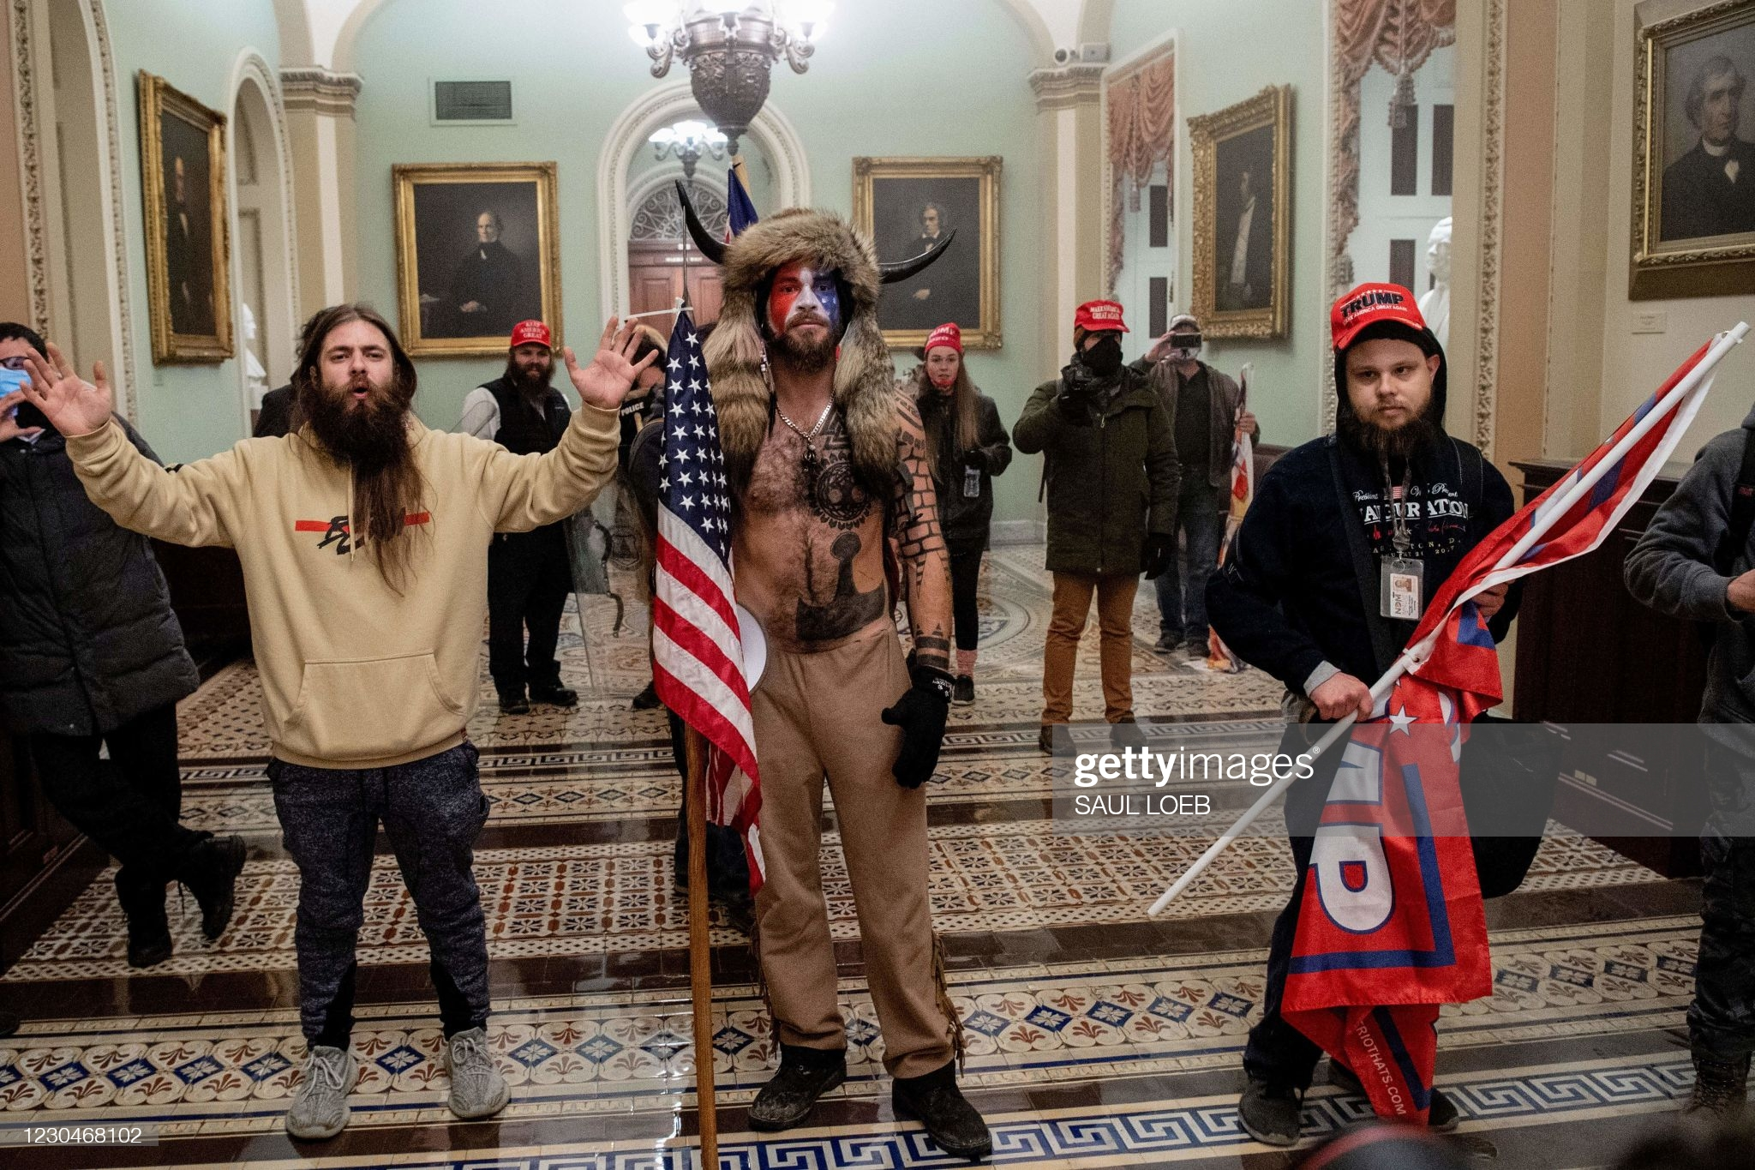
There’s a much bigger problem with this QAnon dude, though. I admit I was oblivious to it because I was too distracted by the prominent valknut and Mjolnir. I was angry that this guy would garner attention because he looked absurd in an outfit that was carefully chosen to stand out and make him the focus of media coverage. I overlooked his headwear because it’s not Nordic, and I was only reacting to the Nordic imagery he flaunted.
And that, I admit, was a very myopic reaction. The imagery this individual embraces isn’t just affecting heathens. It’s hurting groups that have been historically oppressed and tormented by white Americans. There is a much more disturbing aspect to his costume that I’d like to address.

Stop Mocking the Sioux War Bonnet
One of the more prominent scholars in the Northeast Heathen Community, the regional collective to which I belong (and the “Ravens” referenced in my column title) clued me in to something genuinely disturbing. Joshua Rood, PhD Candidate in Cultural Anthropology at University of Iceland, pointed out that this guy’s headdress is a Lakota Sioux war bonnet.
This is hugely problematic. A white male who, according to his Facebook profile appears to be Christian, stormed the U.S. Capitol wearing an indigenous symbol that has to be earned within a tribe and carries with it tremendous spiritual and cultural significance.
To make matters worse, a lot of people on social media are referring to it as a “Viking helmet,” and some heathens are decrying the inaccuracy of a Norseman wearing a horned helmet. Most of the memes and commentary are mocking the “helmet.” Rood made a poignant remark about this (bold emphasis mine):
In doing all of this, a whole bunch of upset white people are drowning out the voices of genuinely marginalized people (Native Americans) and making it about “themselves” and spreading misinformation. . . .
Condemn him. . . . But ALSO use your platforms to give the bonnet back to the Sioux. Stop people from mocking it. Stop them from claiming it is “ours” (even if they mean that it’s a cheesy fantasy version of ours). We don’t like Nazism. We fight against that. And therefore we, more than most people, know what it is like to have our sacred symbols misused.

I’m taking his plea to heart. He followed up on the debate about the headdress being a point of contention in heathen discussions with “[claiming the headgear] belongs to Heathenism.. is a serious problem. It’s non-Natives, talking about Native stuff, without trying to make room for Natives… They are continually silenced by a majority.” Rood urges heathens to correct the comments about the Viking cosplay and give respect to the Sioux to amplify their voices in speaking out against this disgrace. Yes, this QAnon man has brought negative attention to heathens through his tattoos, but he’s also defiling something held very dear and sacred to our Native neighbors while we bulldoze over that hurt by mocking it as a silly wannabe viking helmet.
It’s bad enough that people are referring to the valknut and Mjolnir as “Nazi symbols” and perpetuating the misinformation about what heathenry entails. It’s so much worse than overlooking the blatantly disrespectful misuse of sacred symbols of our land’s already abused and overlooked indigenous people.

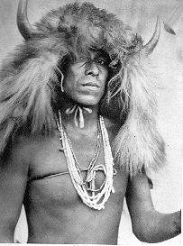Sioux war bonnet, Library of Congress
This “QAnon Shaman” is not heathen. He has no claim to the war bonnet he wears. He is, from what we can tell, a Christian suckered into QAnon tomfoolery with an awful lot of questionable stylistic choices that distract us from the dangers at hand. He carefully crafted his image to draw attention to himself, and he’s hurting multiple communities in the process.
Stop making fun of his headdress, stop whitewashing it. Stop giving him the attention he so obviously wants. He doesn’t deserve it, just as he doesn’t deserve the honor of the war bonnet.

Reaping What You Sow

As for the valknut tattoo? Let’s leave it at this: many heathens recognize it as (among other things) the mark of a sacrifice. There’s a joke in the community that to wear the valknut is to say, “insert spear here.” Interpret that how you will.

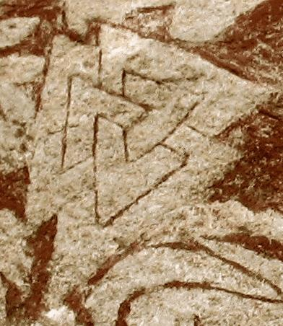Valknut from an image depicting a sacrifice on the Stora Hammars I stone. Image: Wikimedia Commons

